Set a cookie to remember login details

<html>

<body>

<?php

function welcome($msg){

$username='Admin';

die('<h1> Hi '.$username."! You are now successfully logged in!".'<br>

<a href="'.$_SERVER['PHP_SELF'].'?type=logout">Logout</a>'

);

}

$login='no';

if (isset($_COOKIE['username'])) $login='yes';

if ($_GET['username']='Admin' && $_GET['password']='12345')

setcookie('login','true',time()+3600);

$login='yes';

if ($_GET['type']=='logout'){

setcookie('login','',time()-3600);

$login='no';

}

if ( $login=='yes')

welcome ('You are successfully logged in!');

?>

<center>

<form action="<?php echo $_SERVER['PHP_SELF'].'?type=login'?>" method="post" ><h1>Login</h1>

Username: <input type='text' size='15' maxlength='25' name='username' value="Admin">

Password:

<input type='password' size='15' maxlength='25' name='password' value="12345">

<br><br>

<input type="submit" value="Login">

</form>

</body>

</html>

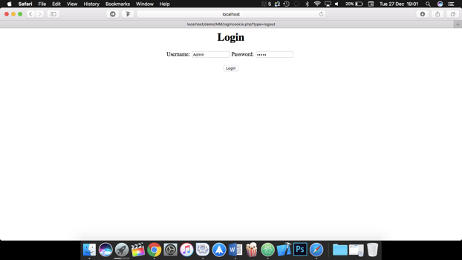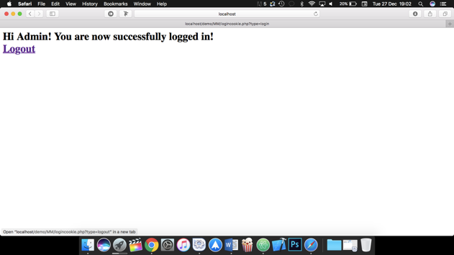

Using Sessions

In this example a random number is made and saved to a session; based on its value, a message is shown. If it is bigger than 5000, the 'ID' session is removed and the 'lottery' session is set to 'no'; otherwise it will be kept and 'lottery' session is set to 'yes'. Finally all data is removed.

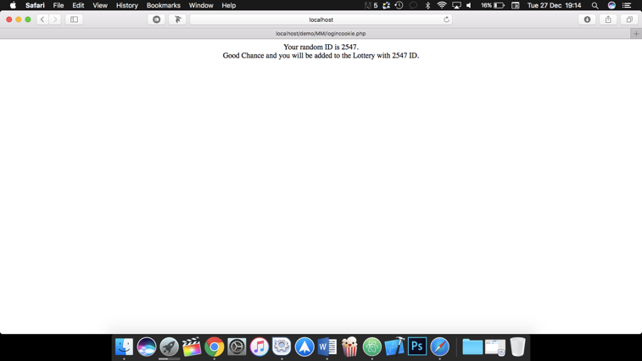

<html>

<body>

<center>

<?php

session_start();

$a= rand(1000, 9999);

echo "Your random ID is $a.<br>";

$_SESSION['ID']= $a;

if ($a>=5000) {

session_unset('ID');

echo 'Sorry Bad Chance.';

$_SESSION['lottery']= 'no';}

else{

$b= $_SESSION['ID'];

echo "Good Chance and you will be added to the Lottery with $b ID.";

$_SESSION['lottery']= 'yes';}

session_destroy();

?>

</center>

</body>

</html>

Find matched strings and highlight them

<html>

<body>

<center>

<form action="<?php echo $_SERVER['PHP_SELF']; ?>" method="post">

ENTER THE TEXT: <input type=text name=t1>

<br><br>

THE STRING TO BE FOUND: <input type=text name=t2>

<br><br>

<input type=submit name=b1>

</form>

<?php

$txt=$_POST['t1'];

$find=$_POST['t2'];

echo 'The search expression is found at <br>';

$replace="<font color=red>$find</font>";

echo str_replace($find,$replace,$txt);

?>

</center>

</body>

</html>

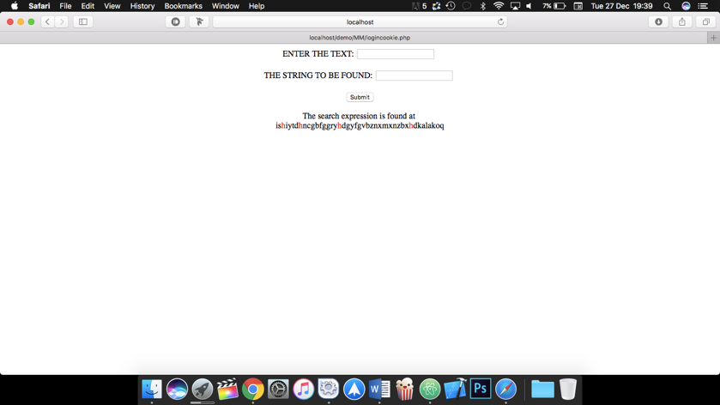

PHP Form Validation

<html>

<head>

<style>

.error {color: #FF0000;}

</style>

</head>

<body>

<?php

$nameErr = $emailErr = $websiteErr = "";

$name = $email = $website = "";

if ($_POST['name']=="") {

echo '<p class=error>'."Name is required!".'</p><br>';

}

if ($_POST["email"]=="") {

echo '<p class=error>'."Email is required".'</p><br>';

}

if ($_POST["website"]=="") {

echo '<p class=error>'."Website is required".'</p><br>';

}

?>

<h2>PHP Form Validation</h2>

<p class="error">All fields required.</p>

<form method="post" action="<?php echo $_SERVER['PHP_SELF'];?>">

Name: <input type="text" name="name">

<br><br>

E-mail: <input type="text" name="email" >

<br><br>

Website: <input type="text" name="website" >

<br><br>

<input type="submit" name="submit" value="Submit">

</form>

<?php

echo "<h2>Your Input:</h2>";

echo $name;

echo "<br>";

echo $email;

echo "<br>";

echo $website;

?>

</body>

</html>

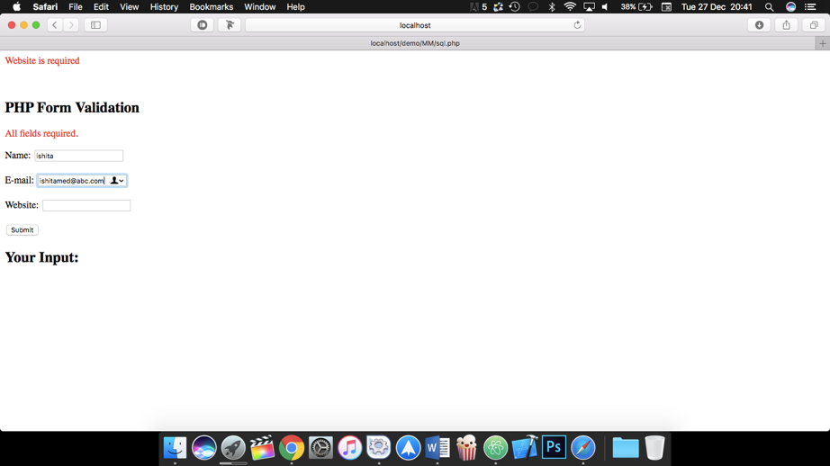

Palindrome Finder (JavaScript)

<html>

<head>

<style type="text/css">

.h{background:#8BC34A;color:#ffffff;font-size:60;font-family:"helvetica neue"}

.b{background:black;color:#ffffff;font-family:arial;font-size:20}

</style>

<body class=b>

<center>

<h1 class=h> Palindrome </h1>

<form name="frm">

Enter a String/Number: <input type="text" name="string" />

<br />

<input type="submit" value="Check" onclick="Palindrome();"/>

</form>

<script type="text/javascript">

function Palindrome() {

var revStr = "";

var str = frm.string.value

var i = str.length;

for(var j=i; j>=0; j--) {

revStr = revStr+str.charAt(j);

}

if(str == revStr) {

alert(str+" is Palindrome");

} else {

alert(str+" is not a Palindrome and its reverse is " + revStr );

}

}

</script>

</center>

</body>

</html>

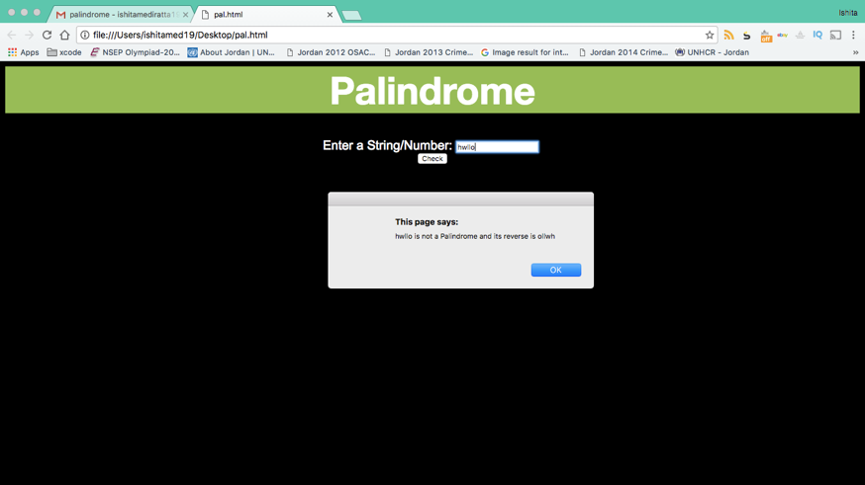

Javascript Clock

<html>

<head>

<style type="text/css">

.b{background:black;color:#ffffff;font-family:arial;font-size:20}

</style>

<script type="text/javascript">

function startTime() {

var today = new Date();

var h = today.getHours()

var m = today.getMinutes()

var s = today.getSeconds()

var ampm = "AM"

if(h>12){ampm = "PM";

h=h-12;

}

if(h==0){

h=12;

}

document.timer.clock.value = h+":"+m+":"+s+" "+ampm;

var t = setTimeout(startTime,500)

}

</script>

</head>

<body class=b onLoad="startTime()">

<center>

<h1> The Time is:</h1>

<form name="timer">

<input type="text" name="clock">

</form>

</center>

</body>

</html>

